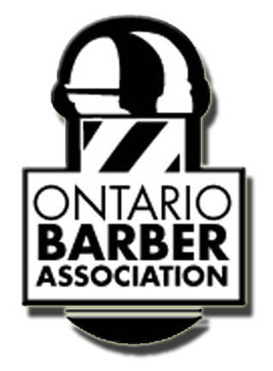


To whom it may concern:

Barbers remain displaced with no mechanism to help acclimate Professional Barbers into the current Apprenticeship/Training & Skills Development category. As the Ontario Barbers Association, we have been waiting for the development of an implementation plan. We’re requesting new "scope limited" provisional Certificate of Qualification as a pathway for uncertified Barbers to become certified members of the Hairstylist trade without having to demonstrate competency in the full scope of the Hairstylist trade. With the thousands of barbers displaced since 2013 and current barbers that have been awaiting a decision from the public consultation, it is our view that supporting the creation of such a Certificate of Qualification is at this time is within the public’s best interest.

It’s been 46 years since barber has been absent from Ontario’s education system. Barber standards, barber skill sets, barber trade Equivalency Assessments, scope of practice for “barbers”, barber best practices, barber learning outcomes have all been either removed or eradicated by industry and government. (The designation Barber and Black [ethnic specific hair] hair was eradicated in 1991) This needs to be modernized and updated to reflect the diversity of Ontario. Suggesting Barbers & hairstylist are the same is not acceptable.

Thank you

